

2016-2017 Chapter Sponsors – Thank you!

GOLD LEVEL
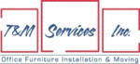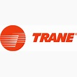

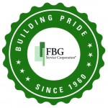

Silver LEVEL


BRONZE LEVEL
