
2016-2017 Chapter Sponsors – Thank you!
Please Support Our Generous Sponsors
Sponsor Information on EI-IFMA Website

GOLD LEVEL
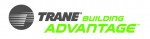


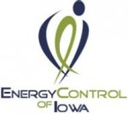
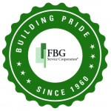

Silver LEVEL
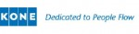
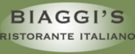
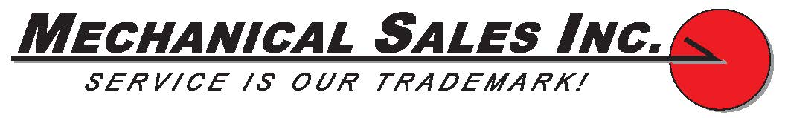

BRONZE LEVEL
